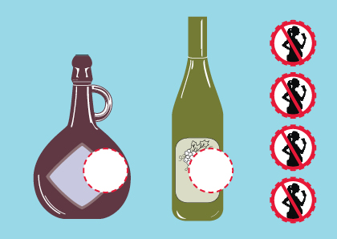
Europe-wide action for labels on alcoholic beverages to warn women not to consume alcohol during pregnancy
Organizations and individuals in over 20 European countries are calling for messages on alcoholic drinks to warn women not to drink during pregnancy. In the coming days, 15 000 postcards illustrating the demand for warning labels will be sent to national and EU health ministers and policymakers or distributed to the general public throughout Europe.

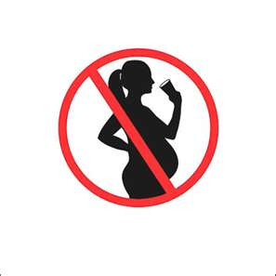
The postcards show outlines of bottles of alcoholic drinks with stickers provided to stick onto the bottles. The stickers carry the internationally recognized warning pictogram. Either this pictogram or a warning text are mandated on alcoholic beverages sold in France. In other countries, some brands bear labels, but most do not. We believe that all European women have the right to know of the dangers of drinking during pregnancy. We support standardized, mandatory health warning labels on containers of alcoholic drinks and on advertisements for these products.

Drinking alcohol during pregnancy can cause brain damage and physical birth defects to the unborn child. The whole range of these effects is known as Fetal Alcohol Spectrum Disorders (FASD). FASD is believed to affect at least 1% of babies born in Europe. Both the European Union and the World Health Organization have made it a priority to protect the unborn child from prenatal exposure to alcohol. According to the Eurobarometer Survey of 2006, 77% of European citizens support labels to warn the public of the risks of drinking during pregnancy.

Contact: Your name, organization, website, telephone number.
Facebook: fb.com/alcohol.labels
Twitter: @alcohol_labels
Step-by-step plan for Labelling Action in December 2011
Now:
Translate the attached press release and letter into your own language. Adapt these as necessary to reflect the situation in your country and be sure to include a contact telephone number so that reporters can reach you for more information.
Find the address of your health minister and other relevant ministers or leaders. We will provide the addresses of the relevant EU contacts. Prepare letters for these people—but don’t send them yet!
Prepare your postcards: translate the message into your language, and include your website. If you like, you can print this information on stickers, and just stick them to the card. If you are not sure how to do this, contact diane.black@fasstichting.nl.
Ask friends and colleagues to prepare postcards, too. The more cards received by the policymakers, the better!
Ask a few of your members or friends and family to help distribute postcards in shopping areas in the month of December. Yes, December is a busy time. It will make a difference if each person can spend even 15 minutes distributing flyers in a buy area—or just leave a few on the info table at your local grocery store, liquor store, or family doctor’s office.
November 30: Send out the press release, making sure you include a telephone number where you can be reached for more information. Send out letters or postcards to your health minister and other relevant contacts.
During December: Distribute postcards in shopping areas.
If you buy bottles of alcoholic drinks in December, look for the labels. Tell your store manager or the person at the checkout that you are buying only drinks with the label.
ENJOY A WONDERFUL HOLIDAY PERIOD, KNOWING THAT YOU HAVE HELPED TO PREVENT FASD AND PROMOTE LABELLING!
Herman Van Rompuy
President of the Council
European Council
Rue de la Loi 175,
B-1048 Brussels
BELGIUM

Jo Leinen
Chair of ENVI Committee
European Parliament
Bât. Altiero Spinelli 12G205
60, rue Wiertz / Wiertzstraat 60
B-1047 Bruxelles/Brussel
BELGIUM

Jerzy Buzek
President of the European Parliament
European Parliament
Bât. Paul-Henri Spaak 11B011
60, rue Wiertz / Wiertzstraat 60
B-1047 Bruxelles/Brussel
BELGIUM

Jose Manuel Barroso
European President
European Commission
B-1049 Brussels
BELGIUM

Mr John Dalli
European Commissioner for
Health and Consumer Policy
European Commission
B- 1049 Brussels
BELGIUM

Paola Testori Coggi
Director General for Health and
Consumers
European Commission
Directorate for Health and Consumers
B-1049 Brussels
BELGIUM

Martin Seychell
Deputy Director General for Health and
Consumers
European Commission
Directorate for Health and Consumers
B-1049 Brussels
BELGIUM

Jacqueline Minor
Director for Consumers Affairs
European Commission
Directorate for Health and Consumers
B-1049 Brussels
BELGIUM

Despina Spanou
Special Advisor
European Commission
Directorate for Health and Consumers
B-1049 Brussels
BELGIUM

Basil Mathioudakis
Head of unit
European Commission
Directorate for Health and Consumers
B-1049 Brussels
BELGIUM

Michael Huebel
Head of Unit
European Commission
DG Health & Consumers
SANCO C4 Health Determinants
Rue Alcide Gasperi
L-2920 Luxembourg
LUXEMBOURG

